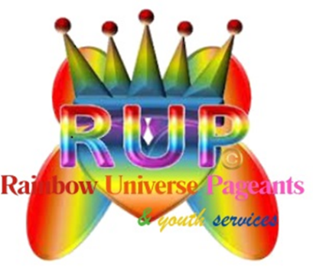
Position Title: Face of RUPYS Spokesmodel
Program: Inner Beauty Pageant System for Rainbow Universe Pageants & Youth Services
Position Type: Temporary, Part-Time (Six-Month Term)
Eligibility: Open to Males and Females, Ages 17–24

Position Overview
The Face of RUPYS Spokesmodel serves as an official ambassador and public representative of the Inner Beauty Pageant System. This individual embodies the values of confidence, character, leadership, service, and authenticity. The Spokesmodel supports brand visibility, community engagement, youth empowerment initiatives, and program promotion through appearances, digital content, and outreach efforts.
This is a temporary, six-month role designed to provide leadership development, public speaking experience, and professional exposure within the pageantry, youth development, and nonprofit space.

Key Responsibilities
- Represent the Inner Beauty Pageant System at approved events, workshops, orientations, and community engagements
- Serve as a positive role model for youth participants across all age divisions
- Participate in promotional campaigns, including photoshoots, videos, interviews, and social media content
- Assist with outreach efforts to schools, community organizations, and youth-serving partners
- Share the mission, values, and impact of the Inner Beauty Pageant System in a professional and articulate manner
- Attend scheduled virtual or in-person meetings, trainings, and appearances during the term
- Collaborate with program leadership, staff, celebrity partners and titleholders as needed
- Uphold brand standards, conduct expectations, and spokesperson guidelines at all times

Qualifications
- Must be between the ages of 17–24 at the start of the interview
- Strong communication and interpersonal skills
- Comfortable speaking in front of groups and/or on camera
- Positive attitude with a demonstrated commitment to self-development and service
- Ability to maintain professionalism on social media and in public settings
- Reliable, punctual, and responsive to communication
- Prior pageant, leadership, ambassador, or youth advocacy experience preferred but not required

Time Commitment
- Six-month service period
- Part-time, flexible schedule based on program needs, event calendar & spokesmodel personal calendar (school, college, personal commitments, etc.)
- Estimated commitment may include evenings, weekends, and occasional travel (as applicable)

Benefits and Opportunities
- Official recognition as an Inner Beauty Pageant System Spokesmodel & the official Face of RUPYS
- Leadership and professional development experience
- Public speaking, media, and branding exposure
- Opportunity to build a resume and professional portfolio
- Mentorship and networking opportunities within the youth development and pageantry community
- Certificate of completion at the end of the term
- Stipend payment of $350 per month (part-time hours) = $2100 total stipend (this amount is subject to change based on organization budget and needs)

Additional Notes
For applicants under the age of 18, parental or guardian consent is required. This role is temporary and does not guarantee ongoing placement beyond the six-month term.

The Inner Beauty Pageant System is committed to fostering confidence, character, and purpose in youth and young adults through empowerment-based programming.

