Empathy 101
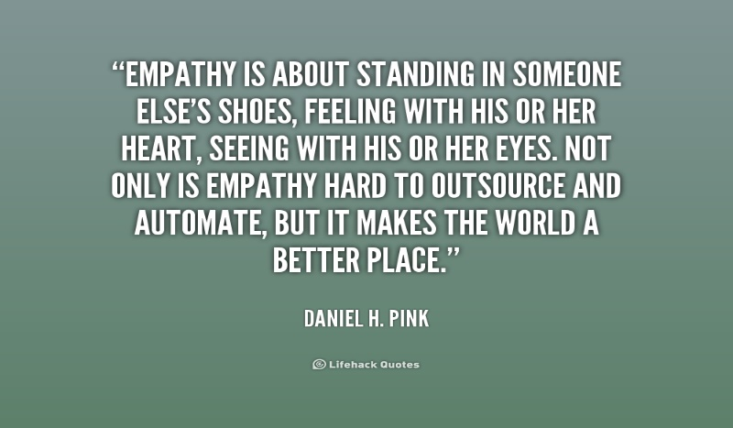

If you happen to be an emotional person or have a hard time expressing empathy or compassion for another person here are some tips that can help you with communicating what is in your heart. If you get scared when someone touches your heart deeply to the point of ignoring them or never letting them know how much you touched their heart then these tips are for you. If you have ever inflicted harm on another person (and who hasn’t) even if it was something as simple as breaking a heart when you didn’t say “thank you” for something or apologize for offending or hurting them (people are sensitive and we have to always take that into account when we interact with others), then these tips will help you. If you find yourself holding grudges and having a hard time forgiving others or seeking revenge all the time because you don’t handle slights or offenses well then read the tips. I know they will help you.

Things to say when someone is hurting or expresses an emotional need or communicates something heartfelt to you:

“I’m so sorry to hear that happened to you. I know if it was me I would feel horrible too”
“I think what you said can resonate with anyone. I feel really sad that that happened and I know you will work it out or be ok because you have the ability to make a difference in your situation.”
“What can I do to help you with your need?”
“I am so sorry for what I did or said. I didn’t mean to hurt you. I want to make it up to you any way I can. Please help me resolve what I did to you.”
“I am so sorry, please forgive me.”
“I read your letter, I got your note, I read your email, I got your text. I am dealing with some major stuff right now emotionally and I wasn’t sure how to respond to you. So I waited and I hope I didn’t hurt your feelings.”
“I am feeling a little scared about what I am feeling for you so I just shut down and didn’t say anything when you expressed your feelings to me. I hope I am not too late in telling you about my feelings.”
“I made a big mistake concerning something I did to you that you may or may not be aware of and I want to apologize and fix it or make it up to you.”
“I felt hurt when you left or when you said what you said so I shut down and didn’t know how to tell you what I was feeling. I want to work this out. I want you to stay in my life.”
“I took something valuable from you a while ago and you probably didn’t know it was me but I want to tell the truth now and hopefully you will forgive me. I don’t want negative karma in my life or negative energy between us.”
“I lied about something I told you and I need to come clean to you because I care about you and I want to make things right between us.”
“I have a ton of emotions flowing through me right now and I don’t know exactly how to deal with everything I am feeling. It’s all new to me but I want you to know what I am feeling and I hope you understand and feel the same way because I want you in my life.”
“I can see that your heart is very broken right now and I want you to know I am sorry for your pain and suffering and I want to be here for you but I am not sure how. Let me know what I can do to show you how much I care.”
“I was rude to you before when you were trying to communicate to me. I was dealing with my own stuff and feeling a little bit insecure so I didn’t respond to you the way you deserved to be responded to. I was taking you for granted and I don’t want to do that anymore because your feelings matter just like mine and I didn’t take what you were going through into consideration. I want to do that now so can we talk?”
“I am not so good at expressing myself and I get really emotional when others are hurting but I will be here for you to listen to your issues because I know you will listen to mine and I do not want you to think I am a selfish person.”
“I know I have been a little bit distant and uncommunicative lately and before but I want you to know how I feel about the kind words you said or the kind gesture you made towards me. It’s just sometimes hard to get words out and express them. I can be very protective of my heart but I don’t want to offend you.”
“I am feeling a little bit jealous of you and I don’t really know how to deal with it. I feel insecure sometimes but I know I am capable of doing what you did or doing something amazing to help others. I didn’t react the way I know you would have wanted me to so I am sorry about that. I don’t want to mistreat you or make you think that I would hurt you because of my jealousy. I know I can squash it and move on so let’s talk about it or just let it go.” – saying something like this takes a very brave and courageous and empathetic person. I am sure you will blow anyone away if you can admit to jealousy without trying to interfere in their lives, sabotage them or hurt them. That is true strength.

Empathy is basically telling the truth and sometimes the truth hurts but when you place yourself in another person’s shoes and try to see where they are coming from or what they are feeling then you will be better able to tell them the whole truth so things don’t get worse and you don’t lose their friendship or that relationship. Get it out as soon as you can. I mentioned before that people die every day in our lives and you don’t want to be telling someone something at their gravestone that you should have told them when they were alive to their face. Don’t wait, don’t waste time, don’t second guess yourself and please don’t be selfish and insecure. If someone needs you or something you have that you can give don’t hesitate in giving it. Something you say could save a person’s life one day, don’t hold it back because you are afraid or can’t seem to deal with someone else’s emotions. Stop thinking so much, get over yourself and just love, no matter what. That is all that matters and that is how you practice empathy.

