Mirror Monologue 
For this activity you will stand in front of a mirror and recite a monologue that you will write yourself. This will be a 3 minute monologue consisting of honest feelings about yourself and your life as it is now. Include the mistakes you have made, your disappointments, any hurt or pain you are feeling now. You will then forgive yourself verbally and recite all of the changes you want to make in your life. This will include improvements, positive behaviors and all of the things you believe you deserve and want in your life. Important note: what you deserve has nothing to do with your behavior – make an effort to look within and see your own pure heart, not what you have done. (Make sure you write out the monologue in first person using “I”. If you choose not to write it down first, it is suggested that you memorize it before you recite anything in the mirror – the key is to face yourself and make eye contact with yourself)
Purpose: to recognize what has held you back in the past and discover what you have in the present to create the future you want; to cultivate a deeper more authentic knowledge of self.

Burn Your Story 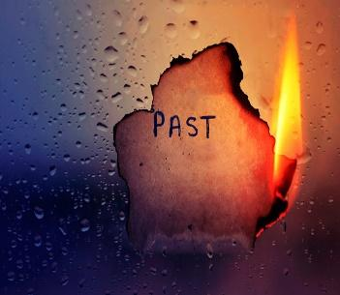
Write a story about your life (unlimited), include all of the bad and negative things that you have experienced or that have happened in your life. Include all past and recent events. Include all of the people that have caused these negative things whether intentional or unintentional and also whether or not the inflictions were the result of your own doing. Read this story to yourself once out loud. Take a moment to soak it all in, the pain, the hurt, the feelings you felt or still feel as a result of these events. Then imagine yourself being free from the bondage of these events. Then light a match and burn your story. (For safety purposes if a match is inappropriate for your setting, cut or rip up your story instead of burning it)

Purpose: to release the past and be open to a new beginning.

Rebirth: Create the Life You Want 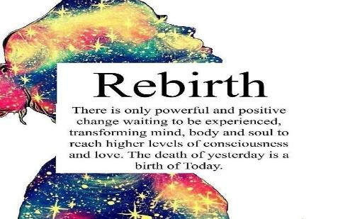
You just burned your old story. Now with this activity you will write your future story with passion and without inhibition (no limit to pages). This will include all of the changes you want or are willing to make in the present to get you to the future you desire. It is suggested that you write with complete abandon, no spell checking, no grammar checking, and no concern about complete sentences. Just write like your life depends on it. Because it does! It’s your life; create what you want it to be!
Purpose: to acknowledge what is not working in your life and create the circumstances, opportunities, and events to make what you want to happen, happen. The passion that you put into this will fuel the fire in you to take the action to get it done.

Rainbow Universe Pageants & Youth Services, LLC. All Rights Reserved. © 2025

